Thank you for your interest in our Toolkit!  Have questions or issues with this document, please contact the  Ontario Food Collaborative at ofc@ontariofoodcollaborative.ca | 

TABLE OF CONTENTS

Page 2 | Social Media “Food Waste” 8 Posts (Text and Images)
Page 6 | Calls to Action x3 (Text Only. No images)
Page 7 | Infographics x3 (Text and Images)
Page 13 | Other Communications Tools
Page 15 | Event Materials
Page 19 | Toolkit Manual Tools
Page 20 | Ontario Guide to Where to Find Community Organizations

This document uses plain text only for universal compatibility.

Social Media “Food Waste” 8 Posts (Text and Images)
Notes: The images and text provided are intended for use on most social media platforms, such as Instagram, X/Twitter, Facebook, and LinkedIn

Social Post #1
Food waste isn’t just about tossing leftovers—it’s wasting natural resources, energy, and money. In Canada, a huge portion of our food never gets eaten, contributing to climate change and landfill waste. Let’s change that! #ReduceFoodWaste #SustainableLiving

According to the Food and Agriculture Organization (FAO), approximately one-third of food produced for human consumption is lost or wasted globally, amounting to about 1.3 billion tons per year. fao.org

Additionally, the United Nations Environment Programme (UNEP) reports that food waste accounts for 8-10% of global greenhouse gas emissions. unep.org

Downloadable image file:
Social Media Food Waste Post 1.png

Social Post #2
Food waste isn’t just about what’s left on your plate—it’s a climate issue. Food waste placed in your green bin creates nutrient-rich soil which can be used to grow more food. Food waste placed in your trash bin ends up in landfills, and creates methane, a powerful greenhouse gas. Food waste in the right place leads to a healthier planet! #ReduceFoodWaste #SustainableLiving #ClimateAction

Downloadable image file:
Social Media Food Waste Post 2.png

Social Post #3
Did you know? Over half of Canada’s food waste comes from households! That’s up to $1,500 worth of food per year per family. (Provision Coalition, 2014)
But there’s good news: you can make a difference!
Plan, Store, Eat, Repeat:
Plan meals to use up leftovers (#planned-overs)
Store food properly to keep it fresh
Eat what you buy before it spoils
[circle arrow emoji] Repeat these steps!
Save your food, save your money, save the planet!
#ReduceFoodWaste #SaveMoney #SustainableLiving

Downloadable image file:
Social Media Food Waste Post 3.png

Social Post #4
If food waste were a country, it’d be the 3rd largest emitter of greenhouse gases! Small changes in your kitchen can make a BIG impact. #WasteLess (United Nations Food and Agriculture Organization fao.org)

Downloadable image file:
Social Media Food Waste Post 4.png

Social Post #5
Organize Your Fridge Like A Pro!
Want to make your groceries last longer? Fridge organization matters!
Lower shelves = coldest → Keep meats here to prevent spoilage and cross-contamination
Crisper drawers = humidity control → High for greens, Low for fruits
Avoid overstocking! Airflow keeps food evenly chilled
Set fridge to 4°C or below to slow bacteria growth!

A little fridge organization = less waste & more savings! #SmartStorage #LoveYourLeftovers

Downloadable image file:
Social Media Food Waste Post 5.png

Social Post #6
Stop Wasting Good Food!
Did you know that misunderstanding best before vs. expiry dates leads to unnecessary food waste?
Best Before vs. Expiry Dates: Know the Difference!
Best Before Date = Quality Indicator
- Found on most packaged foods
- Food may still be safe after this date if stored properly and shows no signs of spoilage
Expiry Date = Safety Requirement
- Applies to infant formula, meal replacements, and supplements
- Should NOT be consumed after this date
Trust your senses – observe it, smell it, taste it – for best-before dates, but do NOT consume expired products! #FoodSafety #ReduceFoodWaste #KnowTheDifference

Downloadable image file:
Social Media Food Waste Post 6.png

Social Post #7
Turn your food waste into garden gold! Composting recycles waste to enrich soil naturally. If you don’t compost at home, check out all the styles available to try! If not, make sure to follow your city’s Green Bin program! #FoodWasteSolution #SustainableLiving

Downloadable image file:
Social Media Food Waste Post 7.png

Social Post #8 - Carousel (6 slide series)
Small space? No problem! Composting can work for any home. From municipal green bins to backyard composting find the method that suits your lifestyle. #CompostLife #ReduceWaste

Composting: Give Food Waste A Second Life!
Composting keeps food waste out of landfills and turns it into nutrient-rich soil.
There are multiple ways to compost, no matter your space!

Downloadable image files:
Social Media Food Waste Post 8 Carousel Pg 1.png
Social Media Food Waste Post 8 Carousel Pg 2.png
Social Media Food Waste Post 8 Carousel Pg 3.png
Social Media Food Waste Post 8 Carousel Pg 4.png
Social Media Food Waste Post 8 Carousel Pg 5.png
Social Media Food Waste Post 8 Carousel Pg 6.png

Social Post #8 - Animated Carousel (6 slide series)
Social Media Food Waste Post 8 Carousel Animated with Music.mp4

Social Post #8 - Animated Carousel with music (6 slide series)
Social Media Food Waste Post 8 Carousel Animated no Music.mp4

Calls to Action x3 (Text Only. No Images)
CTA #1
Wasting food is like throwing money in the trash. Planning meals, storing food properly, and eating leftovers can save you hundreds every year.
#ReduceFoodWaste #SaveMoreWasteLess
Visit (link of municipalities website/webpage) to download your meal planner and other helpful tools today!

CTA #2
Small changes = big impact! Plan meals and freeze leftovers. Reducing food waste helps your wallet and the planet! #ReduceFoodWaste #LoveYourLeftovers #FoodMatters
Visit (link of municipalities website/webpage) to download your meal planner and other helpful tools today!

CTA #3
Plan, store, and eat smart! Proper storage & meal planning can help cut household food waste by up to 50%. Are you up for the challenge? #FoodForThought
Visit (link of municipalities website/webpage) to download your meal planner and other helpful tools today!
Store Smart, Waste Less!
Your fridge has zones—storing food properly keeps it fresher for longer!
Fridge Door = Warmest spot → Condiments & juices
Upper Shelves = Ready-to-eat foods → Leftovers & drinks
Lower Shelves = Coldest spot → Meat, poultry, & fish
Crisper Drawers = Customize humidity → High for leafy greens, Low for fruits
Pro Tip: Keep your fridge at 4°C or below for max freshness & food safety! #FoodStorageTips #ReduceFoodWaste

Infographics x3 (Text and Images)
Notes: Infographics are designed for web display (i.e. webpages, online event pages, etc.) or printed on 11”x14”. Suggested paper type: matte paper, poster paper thickness.

Infographic – “Why Reducing Food Waste Matters”

TEXT in the Image:
Why Reducing Food Waste Matters
Environmental Impact
- Food waste = wasted water, energy, and soil nutrients
- Reducing waste lowers methane emissions and greenhouse gases.
Economic Impact
- Households save money by buying only what they need.
- Businesses reduce costs through better food storage and handling.
Social Impact
- Cultivating a Culture of Sustainability: Reducing food waste encourages a more sustainable mindset. When we view food as a resource that should be used responsibly, it promotes environmental stewardship.
- Corporate Responsibility: Reducing food waste as part of corporate social responsibility programs can have a ripple effect, influencing other companies and encouraging broader systemic change so businesses are accountable for their waste practices.

Food Waste in Canada
396 kg of food waste per person per year (That’s the weight of a full-grown horse!)
31% of avoidable wasted food is fruits and vegetables
Where Food Waste Happens
Households: 47% of food waste
Farms: 10% (Cosmetic imperfections, low demand)
Processing and Packaging: 20%
Grocery Stores: 10%
Restaurants and Food Services: 9%
Distribution: 4%

Let's work together to reduce food waste and make a positive impact!

Downloadable image file:
Infographic - Why Reducing Food Waste Matters.png

Download and customize with your logo (Example placement below)
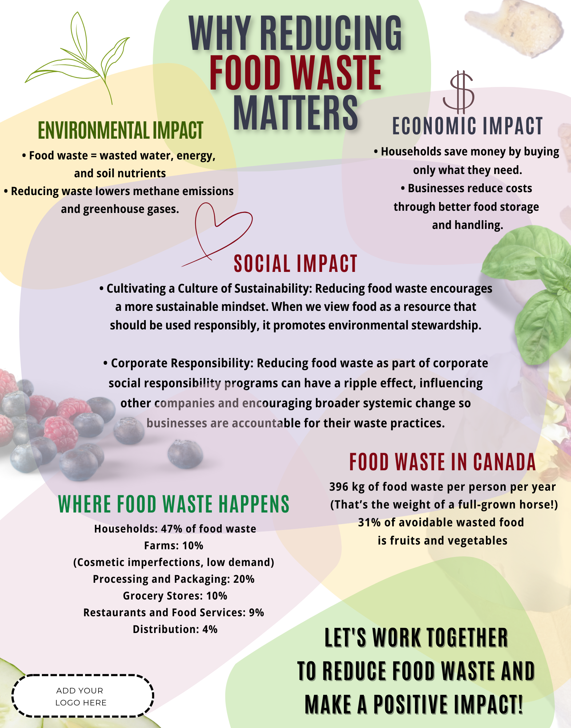

Infographic – “Reducing Food Waste at Home”

TEXT in the Image:
Reducing Food Waste at Home
Environmental Impact
- Food waste = wasted water, energy, and soil nutrients
- Reducing waste lowers methane emissions and greenhouse gases.
Economic Impact
- Households save money by buying only what they need.
- Businesses reduce costs through better food storage and handling.
Social Impact
- Cultivating a Culture of Sustainability: Reducing food waste encourages a more sustainable mindset. When we view food as a resource that should be used responsibly, it promotes environmental stewardship.
- Corporate Responsibility: Reducing food waste as part of corporate social responsibility programs can have a ripple effect, influencing other companies and encouraging broader systemic change so businesses are accountable for their waste practices.

Avoidable vs. Unavoidable Waste
Avoidable (Edible) – Food that could have been eaten (e.g., leftovers, spoiled produce) Unavoidable (Inedible) – Food parts we don’t eat (e.g., peels, eggshells, bones)

Simple Ways to Reduce Food Waste
Plan Your Meals: Buy only what you need
Store Food Properly: Extend shelf life with proper storage
Get Creative with Leftovers: Turn extras into new meals
Compost Scraps: Give waste a second life in the garden
Let's work together to reduce food waste and make a positive impact!

Downloadable image file:
Infographic - Reducing Food Waste at Home.png

Download and customize with your logo (Example placement below)
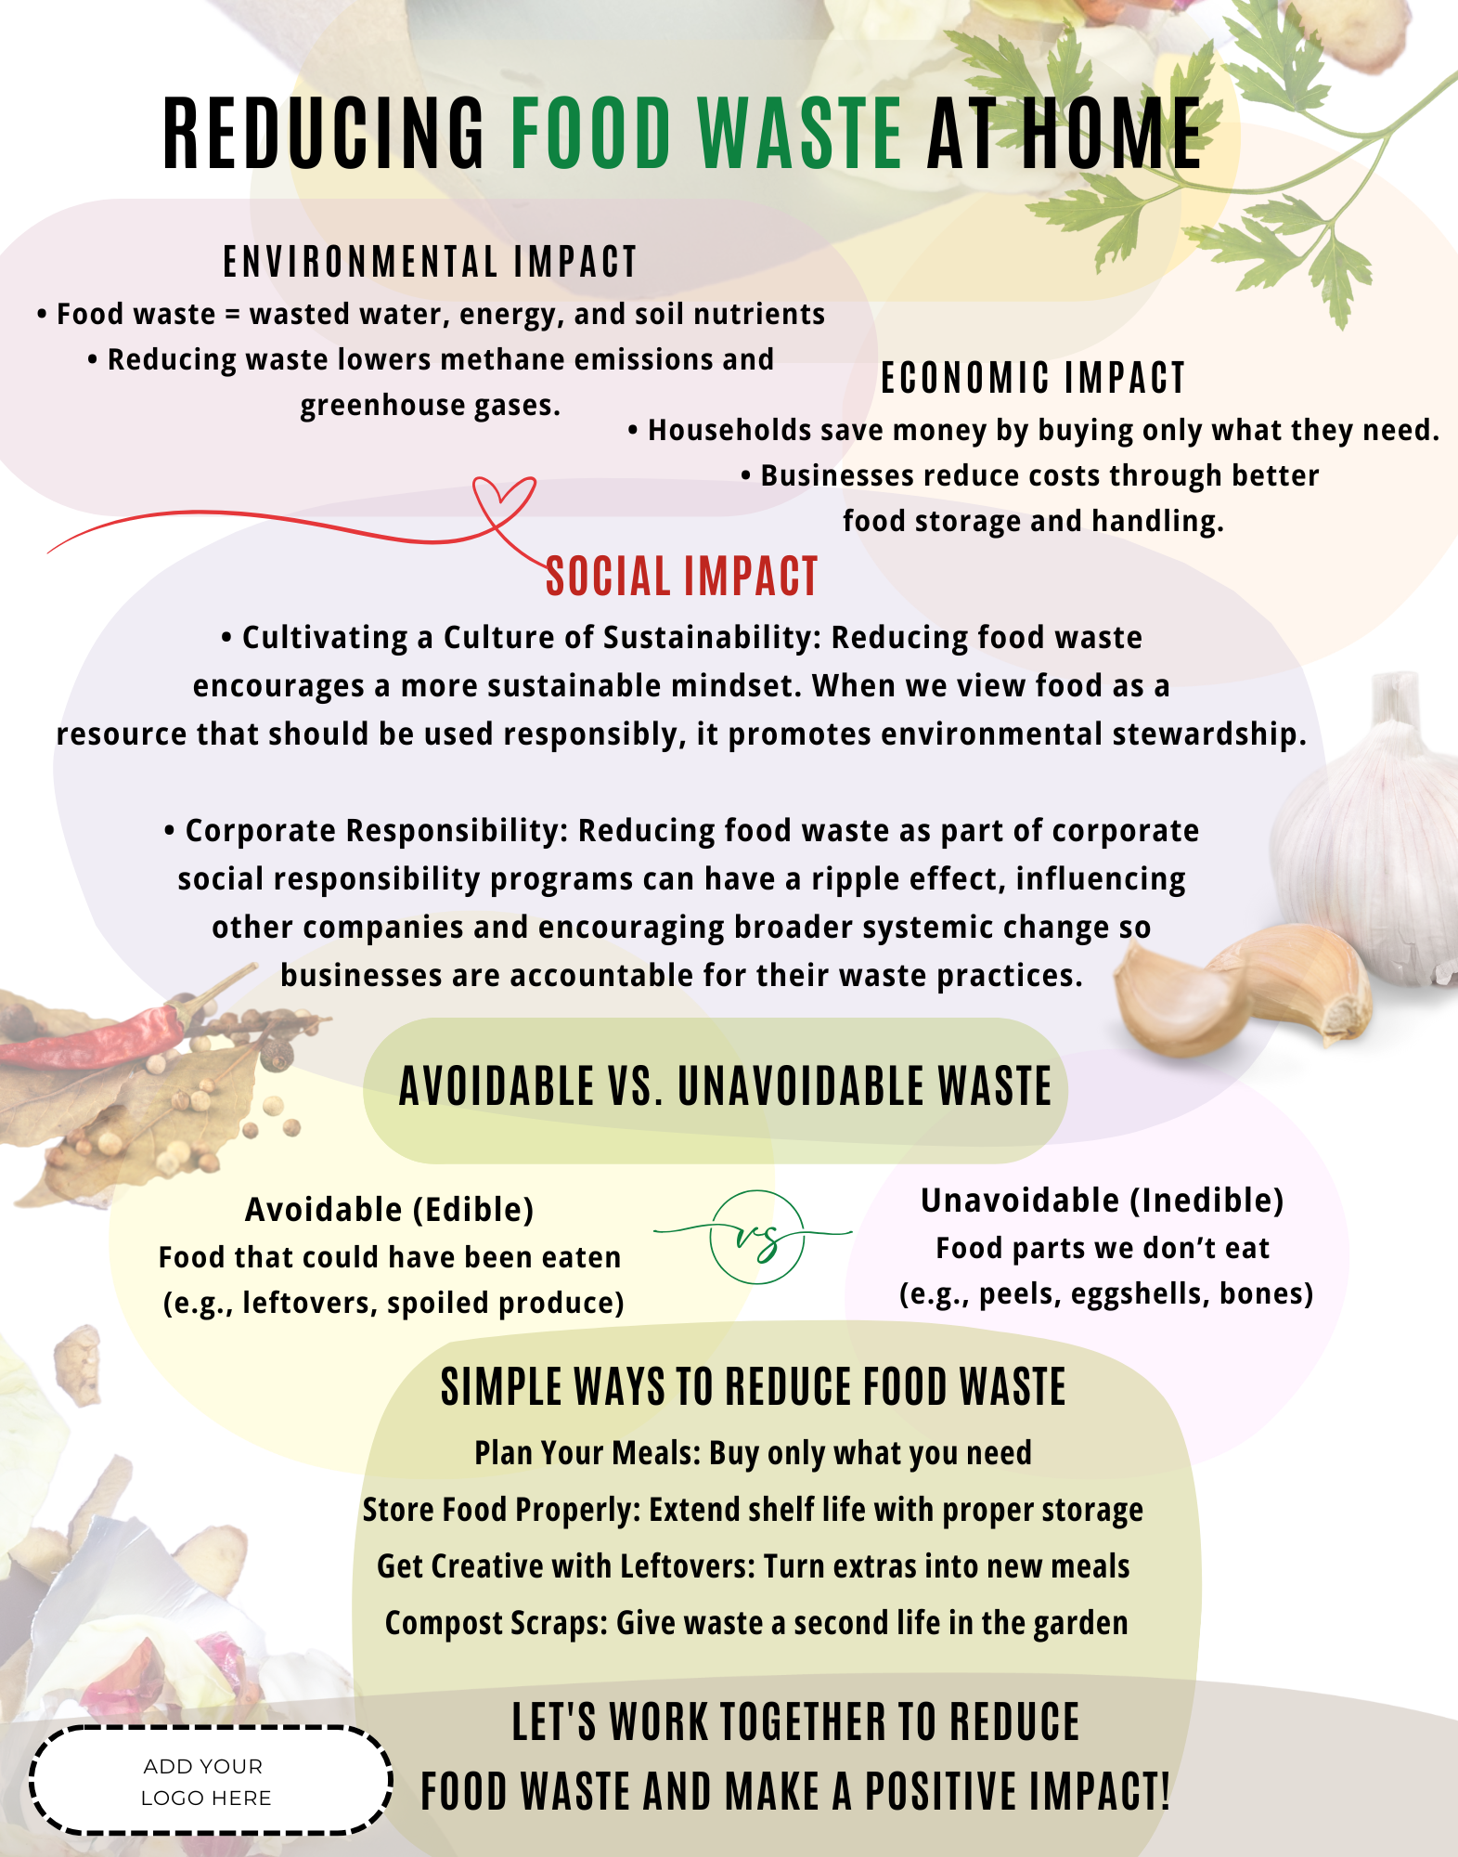

Refrigerator Infographic –” How to Store Food in Your Fridge the Right Way”

TEXT in the Image:
Top Shelf - Leftovers, beverages, prepared foods.
Deli Drawer - Cheeses, deli meats.
Middle Shelves - Dairy, eggs, milk.
Bottom Shelf - Raw meat, poultry, seafood. Tip: Use trays or sealed containers to catch any drips and prevent cross-contamination.

Set Humidity Level - For fridges with adjustment crisper drawers, use the lever to control humidity. Set one drawer to high humidity (closed – less air flow) for most vegetables, and the other to low humidity (open – more air flow) for fruits and quick-to-rot produce.

Temperature - Set your fridge at 4°C or lower.

The warmest part of the fridge is the door.

Store Smart in The Fridge - Avoid overstocking your fridge so cool air can circulate properly. To keep produce fresh longer, store gas-producing items such as tomatoes, avocados, and kiwis, separately from those that are sensitive to them. Use a loosely tied bag and keep them away from ripe or delicate foods to slow spoilage.

Downloadable image file:
Infographic - Refrigerator Tool.png

Download and customize with your logo (Example placement below)
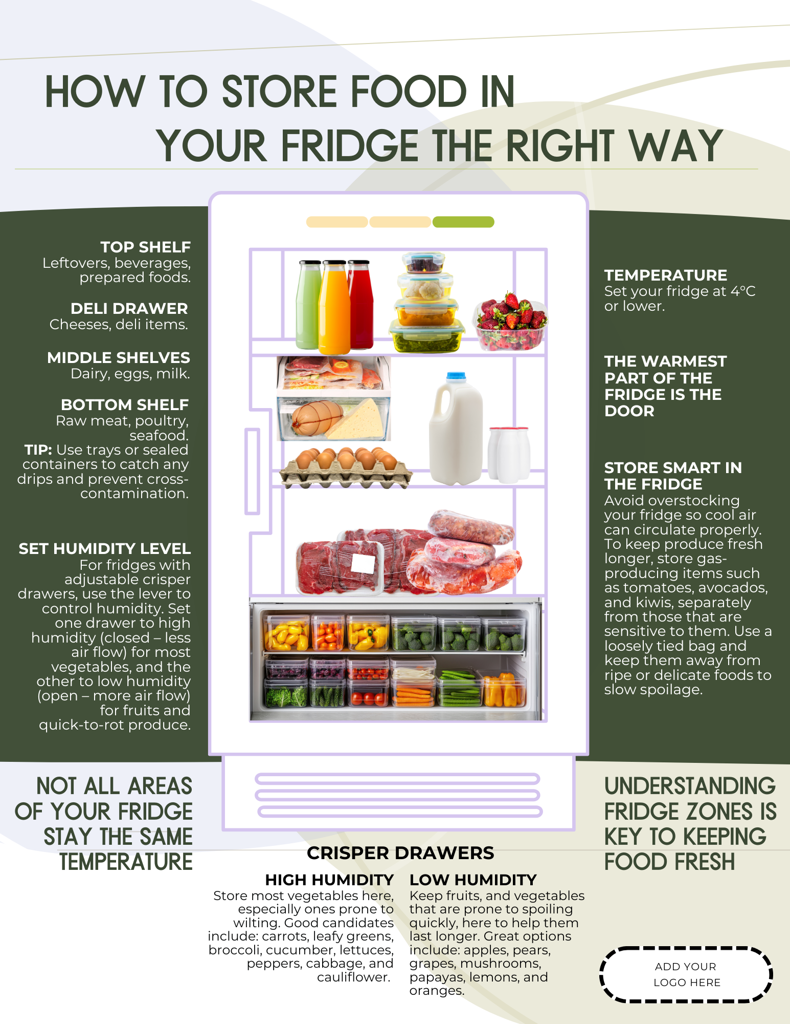

Other Communications Tools

Meal Planning Worksheet (2 pages)

Notes: Optimized for 8.5”x11” paper size. Suggested paper type: matte paper, poster paper thickness.

Downloadable Colour image files:
Meal Planning Page 1.pdf
Meal Planning Page 2.pdf

Download and customize with your logo (Example placement below)
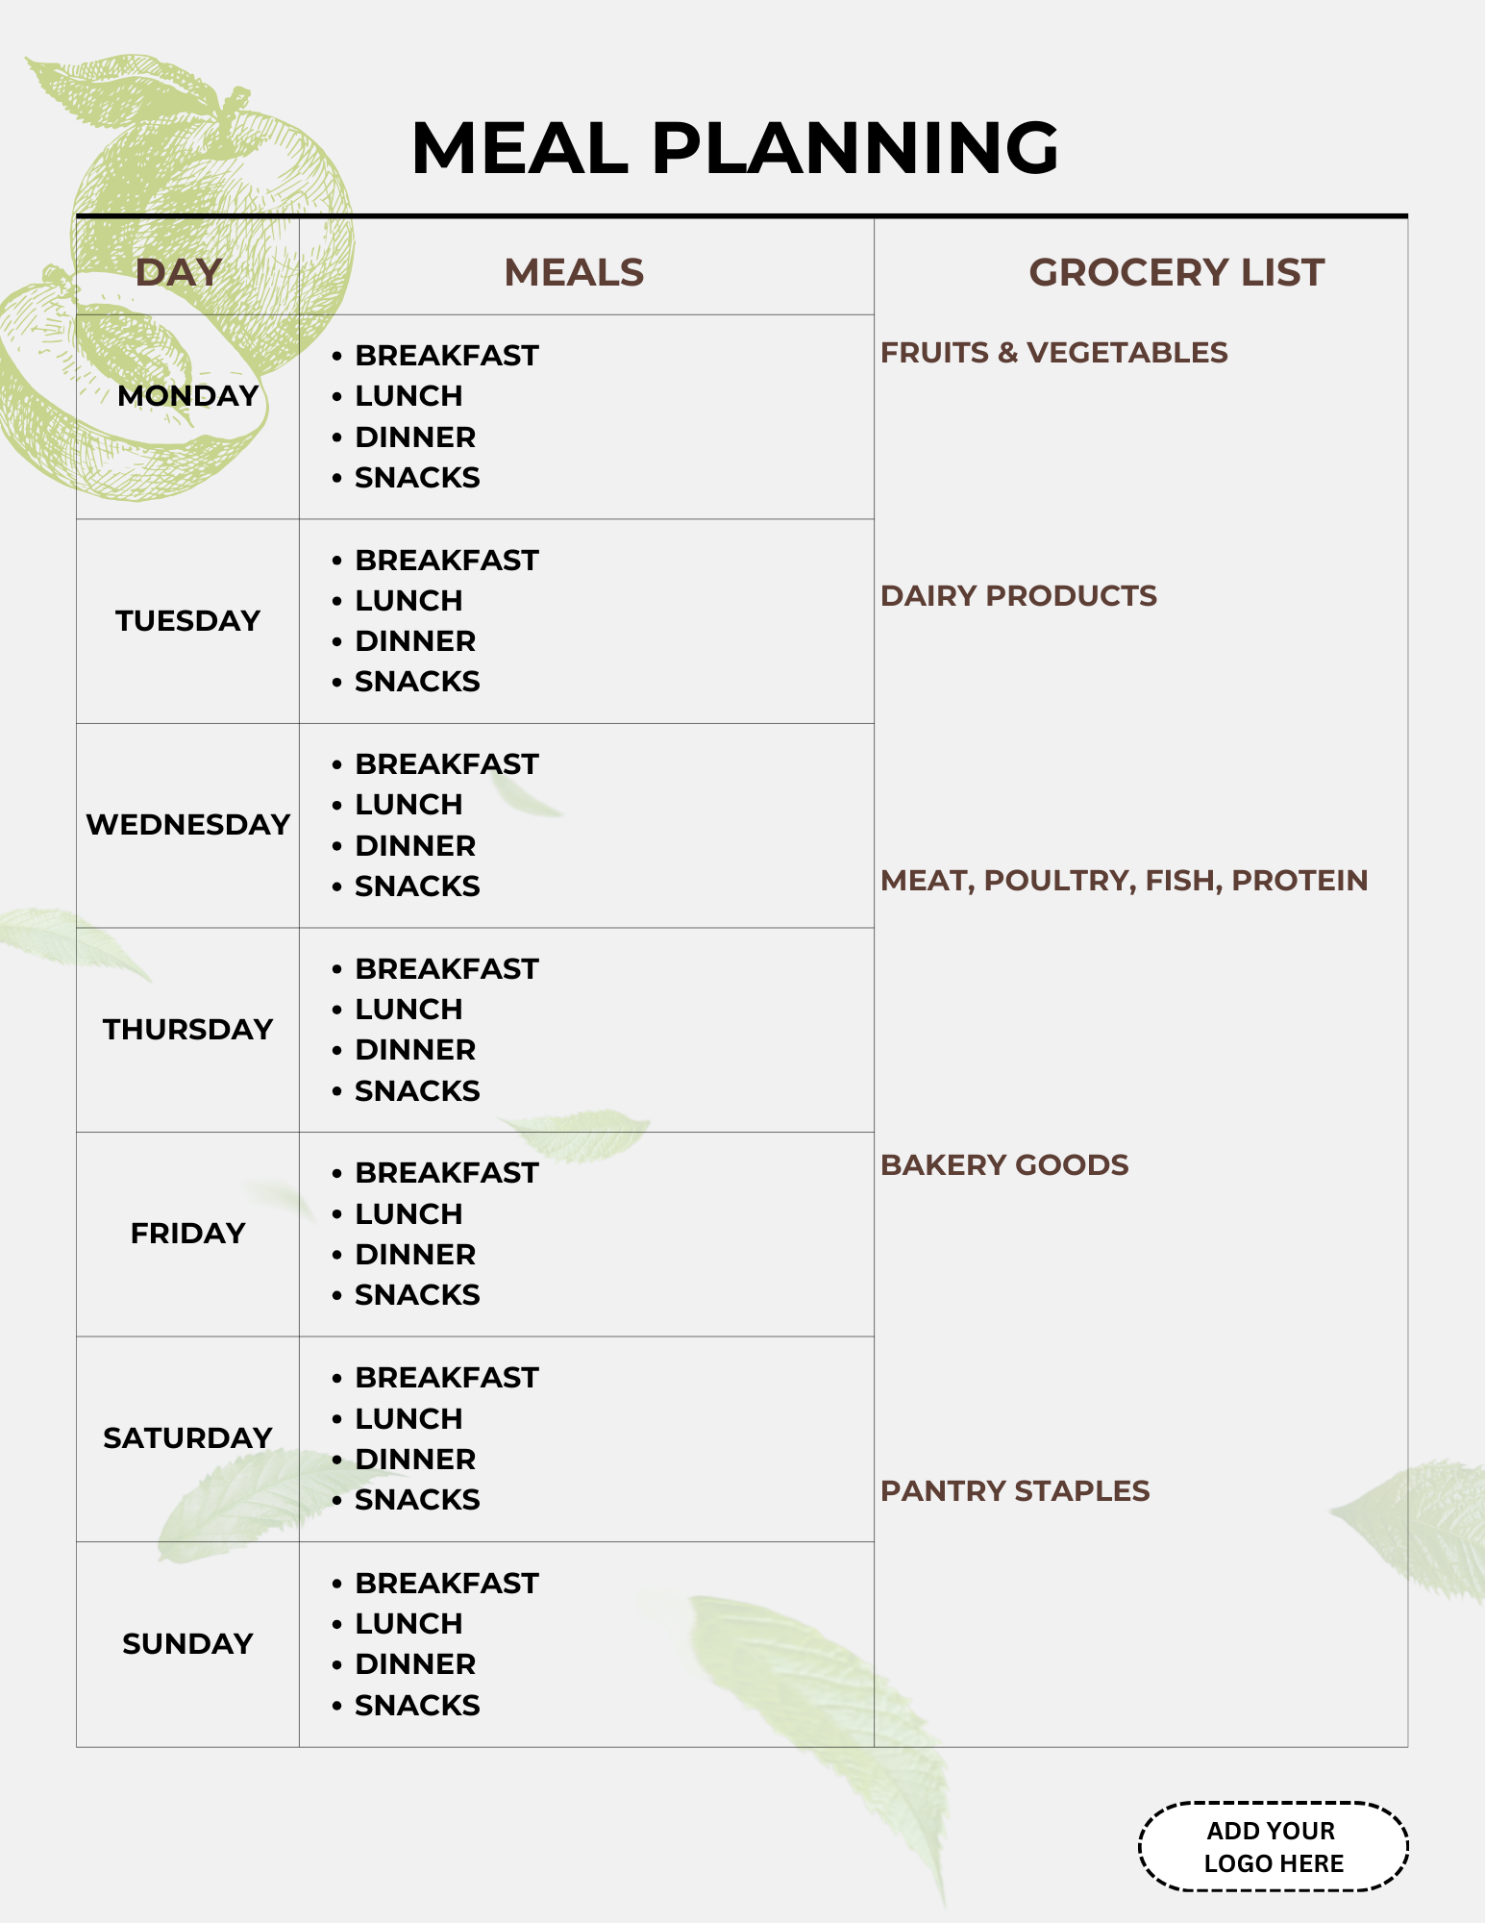
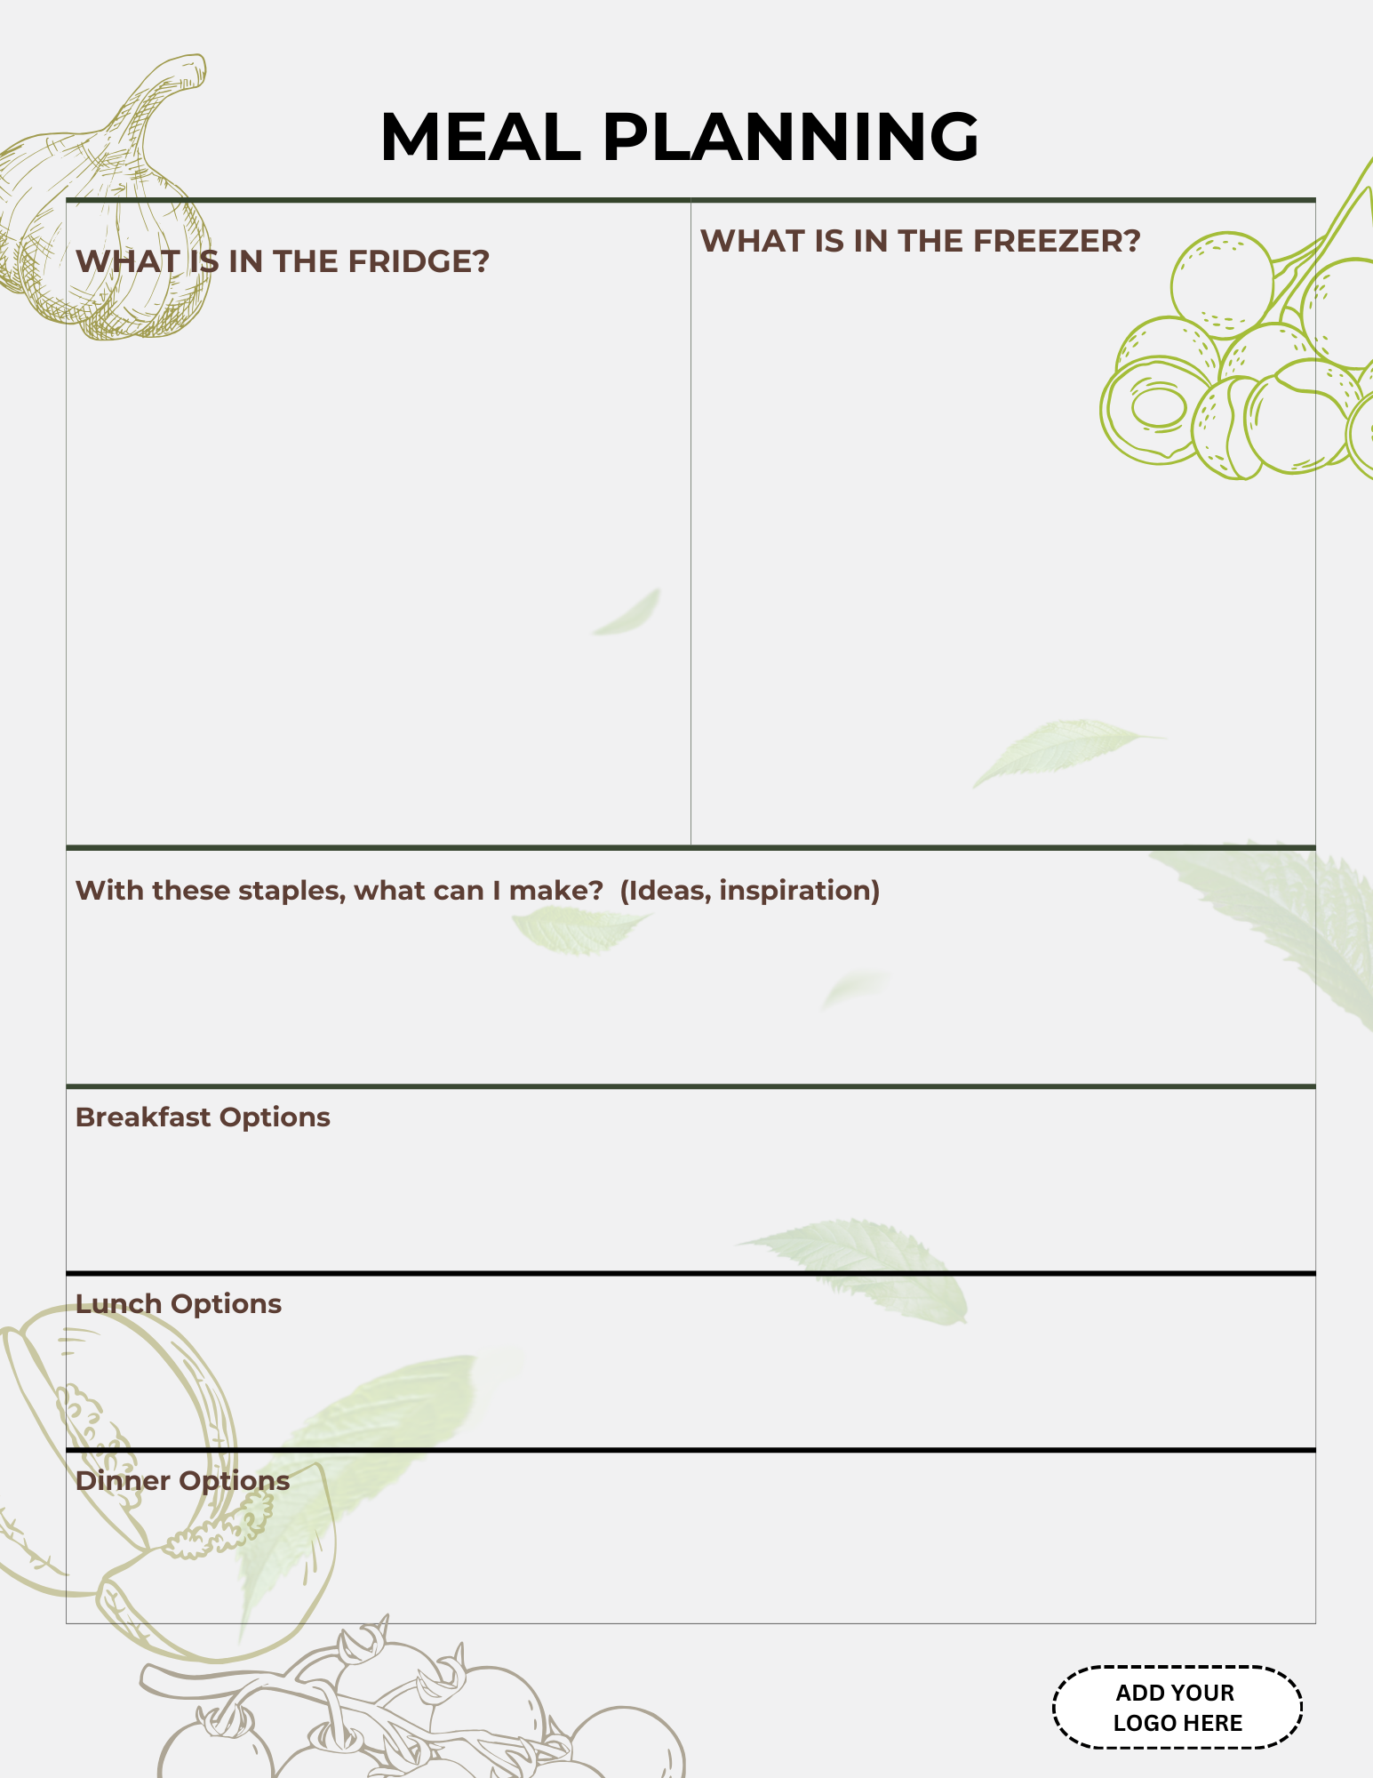

Downloadable Printer Friendly image files:
Meal Planning Printer Friendly Page 1.pdf
Meal Planning Printer Friendly Page 2.pdf

Kids Word Search Puzzle + Answer Key (2 pages)

Downloadable Colour image files:
Activity Page Colour.pdf
Activity Answer Key Colour.pdf

Downloadable Printer Friendly image files:
Activity Page Printer Friendly.pdf
Activity Answer Key Printer Friendly.pdf

Event Materials
Event Posters

Note: Posters are designed for web display (i.e. webpages, online event pages, etc.) or printed on 11”x14”. Suggested paper types: Suggested paper type: matte paper, poster paper thickness. Customizable.

Example Image:

Downloadable image files:
Event Poster Design Option 1.png
Event Poster Design Option 2.png

Event Flyers

Note: Posters are designed for web display (i.e. webpages, online event pages, etc.) or printed on 8.5”x 11” and 8.5”x 5.5” Suggested paper types: matte paper, printer paper. Customizable.

8.5”x 11” Example Image:
Downloadable image files:
Event Flyer 8.5x11 Design Option 1.png
Event Flyer 8.5x11 Design Option 2.png

8.5”x 5.5” Example Image:
Downloadable image files:
Event Flyer 8.5x5.5 Design Option 1.png
Event Flyer 8.5x5.5 Design Option 2.png

Event Postcards

Note: Posters are designed for web display (i.e. webpages, online event pages, etc.) or printed on 4”x5”. Suggested paper types: Card stock, gloss cover paper, recycled cardstock. Customizable.

Example Image:

Downloadable image files:
Event Postcard Design Option 1.png
Event Postcard Design Option 2.png

Event Digital Banner (2 options)

Note: Banner was made with the original 2160 x 1080 pixels. Customizable.

Example Image:

Downloadable image files:
Event Digital Banner Design Option 1.png
Event Digital Banner Design Option 2.png
PowerPoint Templates (2 options)

Design Option 1 Example:

Design Option 2 Example:

Downloadable image files:
PowerPoint Design Option 1.pptx
PowerPoint Design Option 2.pptx

Toolkit Manual Tools
*To download the manual, please visit https://ontariofoodcollaborative.ca/toolkit/

Program and Partnership Prioritization Matrix
Program and Partnership Matrix – Please open the file and go to File → Save As → Save a Copy to create your own version before editing
Program and Partnership Prioritization Matrix Template.xlsm

Partnership Agreement
Partnership Agreement word document - https://ontariofoodcollaborative.ca/wp-content/uploads/2025/09/Partnership-Agreement-Template.docx

Project Budget
Project Budget spreadsheet - https://ontariofoodcollaborative.ca/wp-content/uploads/2025/09/Work-Plan-to-Budget-Template.xlsx

Work Plans
Work Plans spreadsheet - https://ontariofoodcollaborative.ca/wp-content/uploads/2025/09/Workplan-template.xlsx

Evaluation Questions
Evaluation Questions (3 Sheets, full colour, PDF) - https://ontariofoodcollaborative.ca/wp-content/uploads/2025/09/Evaluation-Questions-Full-Colour-3-pages.pdf

Evaluation Questions (3 Sheets, colour, printer-friendly, PDF) - https://ontariofoodcollaborative.ca/wp-content/uploads/2025/09/Evaluation-Questions-Printer-Friendly-3-pages.pdf

Evaluation Questions (3 Sheets, black & white, word document) - https://ontariofoodcollaborative.ca/wp-content/uploads/2025/09/Evaluation-Questions-Black-and-White-3-pages.docx

Ontario Guide on Where to Find Community Organizations
https://ontariofoodcollaborative.ca/wp-content/uploads/2025/09/Ontario-Food-Organizations-February-2024.xlsx

